Voces para UTPL
nfyTTmgO0f6GV9CKrMWL – Valeria
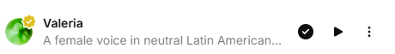
a0MaQpDjx7p7bZmqzFp1

oWSxI36XAKnfMWmzmQok

imFXYz8XIletRKLZZQaA


